Class: Final Year (Computer Science and Engineering)
Year: 2024-25 Semester: 1
Course: High Performance Computing Lab

Practical No. 2
Exam Seat No:21510043
Name:shweta kakade

Title of practical: Study and implementation of basic OpenMP clauses
Implement following Programs using OpenMP with C:
- Vector Scalar Addition
- Calculation of value of Pi
Analyse the performance of your programs for different number of threads and Data size.

Problem Statement 1:
Screenshots:

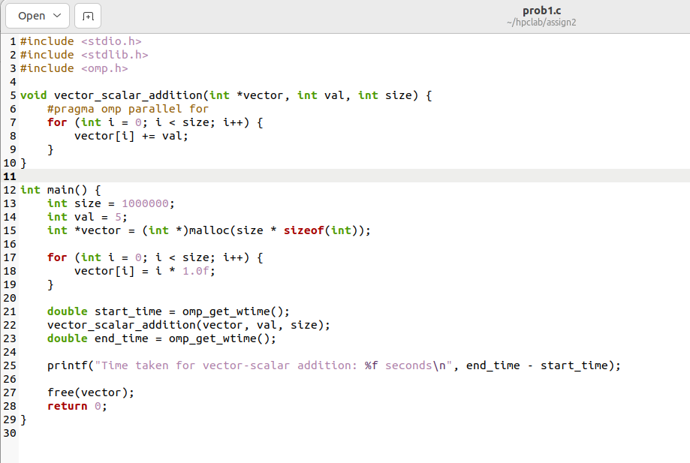

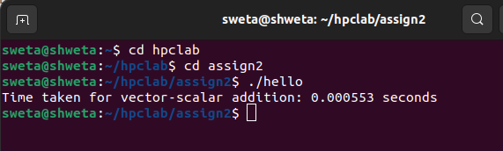

Information:
The program performs vector-scalar addition using OpenMP to parallelize the computation. It initializes a large vector with sequential values, then adds a scalar to each element in parallel.

Analysis:

The time taken for the vector-scalar addition for a vector of size 10,00,000 elements is 0.000553 seconds.For a vector of size 1,00,000 elements, the time is 0.000495 seconds. For a vector of size 1,00,00,000 elements, the time is 0.003931 seconds.
larger vector requires more computations, which generally increases the execution time.

Problem Statement 2:
Screenshots:
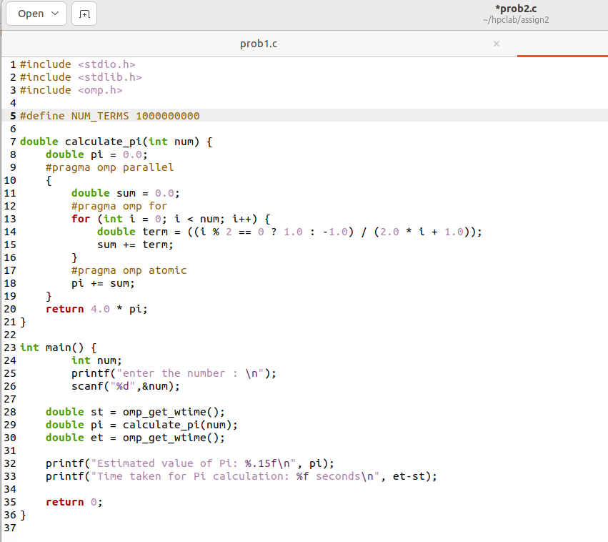
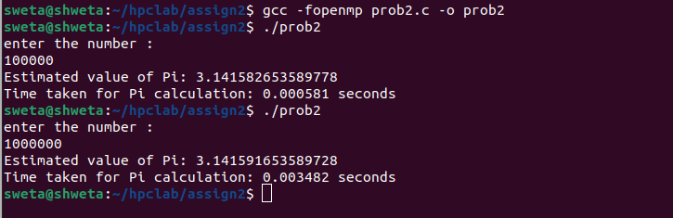

Information:
This C program uses OpenMP to parallelize the calculation of the value of Pi using the Leibniz formula. It divides the computation of terms among multiple threads and aggregates the results to estimate Pi. The user provides the number of terms for the approximation, and the program measures and displays the time taken for the calculation.

Analysis:
The execution time increases with the number of terms like For 100,000 terms, the time taken is 0.000581 seconds. For 1,000,000 terms, the time taken is 0.003482 seconds.
This increase in time is expected because more terms require more computations to sum the series.

Github Link:
https://github.com/shweta29k/HPC_LAB

